
Gnome Street Gnome
Sensors

Tilt switch
Although there are complex boards that will give you an exact angle a tilt switch simply turns on when it’s tilt angle is exceeded.
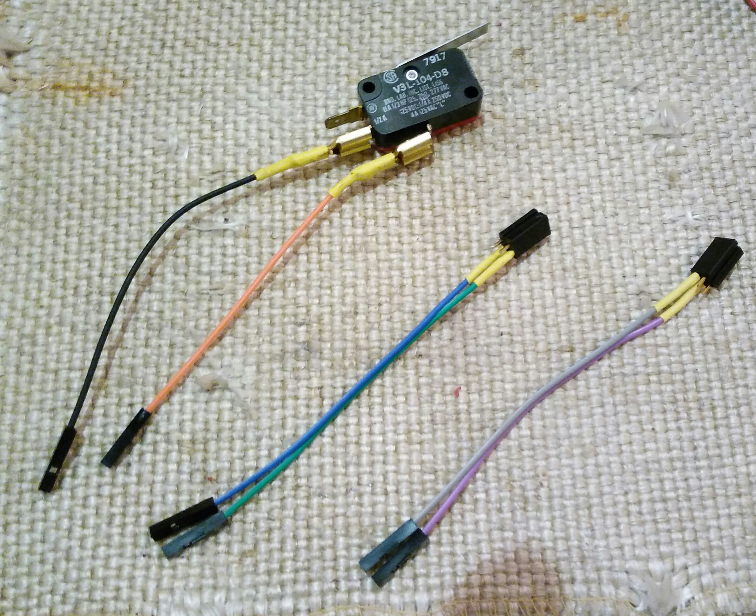
Micro switch
This switch works with a lever, it is good to detect the intended end of a motion.
Light Sensor (LDR)
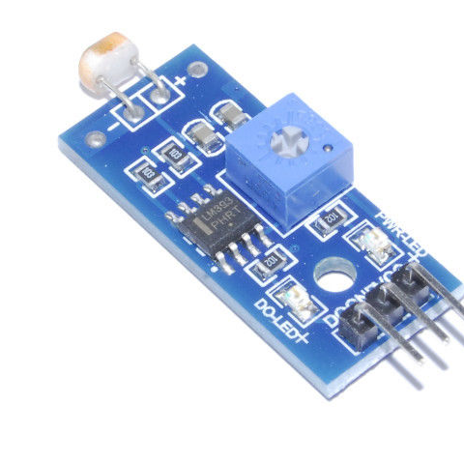
The light sensor is an analogue sensor but with this module it turns into a digital switch. The “pot” allows the level to be set.
Ultrasonic
An ultrasonic sensor can measure position or proximity.

